"""

Created on Thu Jul 5 23:42:36 2018

@author: shubham b thorat

classification to check if a customer invests in the mutual fund or not

"""

#importing libraries

import numpy as np

import pandas as pd

import matplotlib.pyplot as plt

#importing datasets

dataset = pd.read_csv("bank.csv", sep = ";")

X = dataset.iloc[:,:-1].values

Y = dataset.iloc[:,16].values

#using encoding

from sklearn.preprocessing import LabelEncoder ,OneHotEncoder

labelencoder_X = LabelEncoder()

X[:,1] = labelencoder_X.fit_transform(X[:,1])

X[:,2] = labelencoder_X.fit_transform(X[:,2])

X[:,3] = labelencoder_X.fit_transform(X[:,3])

X[:,4] = labelencoder_X.fit_transform(X[:,4])

X[:,6] = labelencoder_X.fit_transform(X[:,6])

X[:,7] = labelencoder_X.fit_transform(X[:,7])

X[:,8] = labelencoder_X.fit_transform(X[:,8])

X[:,10] = labelencoder_X.fit_transform(X[:,10])

X[:,15] = labelencoder_X.fit_transform(X[:,15])

Y = labelencoder_X.fit_transform(Y)

onehotencoder = OneHotEncoder(categorical_features= [1,2,3,4,6,7,8,10,15])

X = onehotencoder.fit_transform(X).toarray()

#splitting dataset into training and testing dataset

from sklearn.model_selection import train_test_split

X_train, X_test, Y_train, Y_test = train_test_split(X,Y, test_size = .1, random_state = 1)

#normalizing

from sklearn.preprocessing import StandardScaler

sc_X = StandardScaler()

X_train = sc_X.fit_transform(X_train)

X_test = sc_X.fit_transform(X_test)

#fitting

from sklearn.linear_model import LogisticRegression

classifier = LogisticRegression(random_state = 0)

classifier.fit(X_train,Y_train)

#predicting

Y_train_test = classifier.predict(X_train)

Y_pred = classifier.predict(X_test)

#confusion matrix

from sklearn.metrics import confusion_matrix

cm = confusion_matrix(Y_test,Y_pred)

"""

#building the optimal model using backward elimination

import statsmodels.formula.api as sm

X_test = np.append(arr = np.ones((453,1)).astype(int),values = X_test , axis = 1)

X_opt = X_test[:,[0,1,2,3,4]]

regressor_OLS = sm.OLS(endog = Y_test , exog = X_opt).fit() #ordinary least square(min_value)

regressor_OLS.summary()

"""

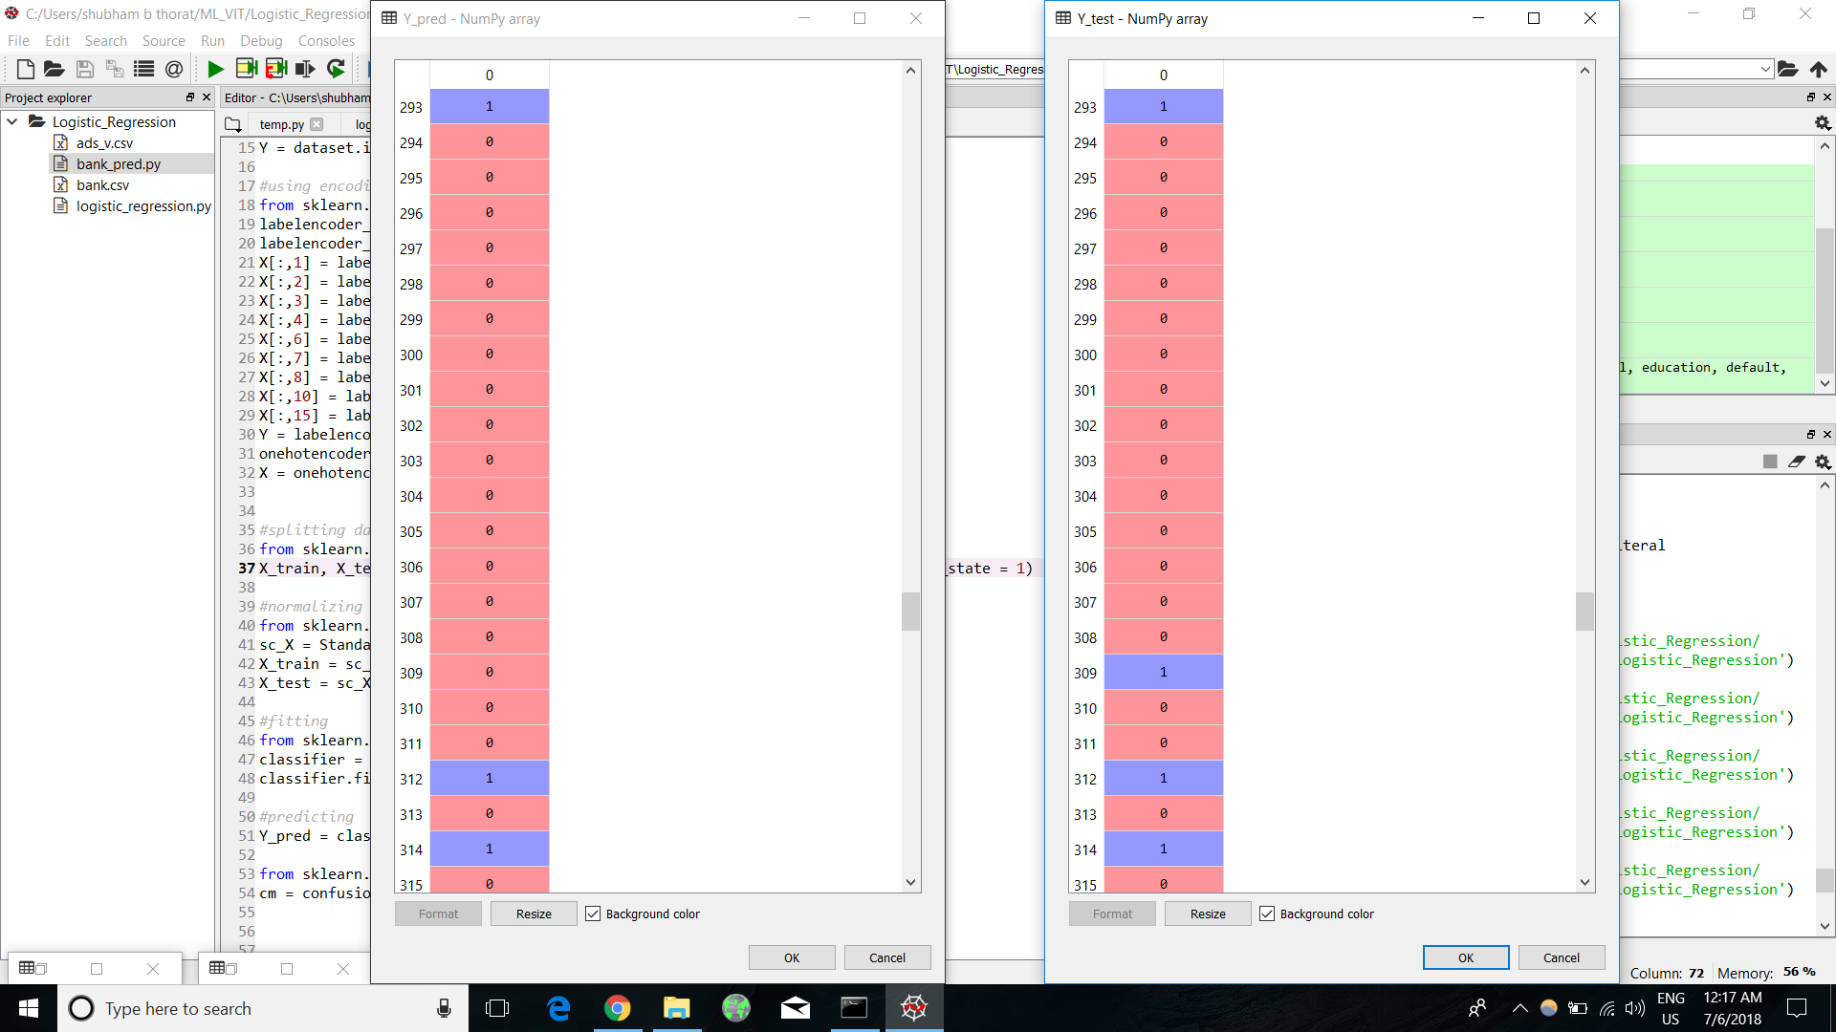

Confusion_matrix

